

Penhill Benefice Church Magazine
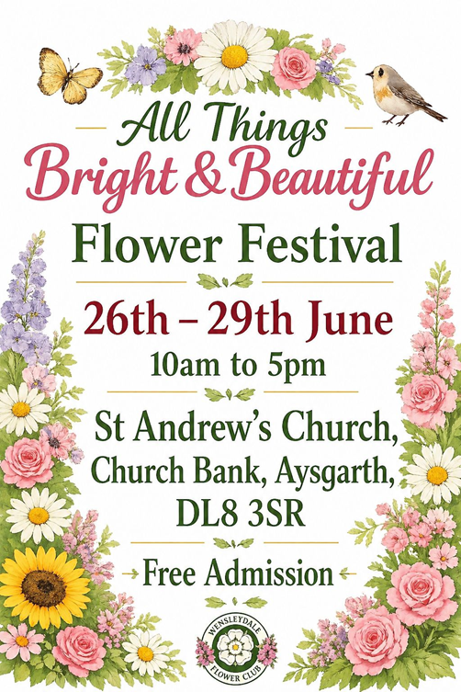
June – July 2026
The Penhill Benefice is committed to show the love of God and the saving grace of Jesus. We share together as the body of Christ, in prayer, worship, ministry and fellowship. In the power of the Holy Spirit we are called to mission and outreach and to be a support and comfort in the community.

Churches of the Penhill Benefice
St Andrew’s, Aysgarth. St Oswald’s, Castle Bolton. St Margaret’s,
Preston under Scar. St Mary’s, Redmire. Holy Trinity, Wensley.
St Bartholomew’s, West Witton and the Mission Room at Thornton Rust.

Vicar: The Revd. Tom Ringland - Tel: 01969 663235
The Vicarage, Carperby, Leyburn, North Yorkshire DL8 4DQ

Associate Vicar: The Revd. Canon Penny Yeadon - Tel: 01969 663505
Dale Cottage, Aysgarth, Leyburn, North Yorkshire DL8 3AB

Curate: The Revd. Scott Lunn – Tel: 07521139838

Churchwardens
St Andrew’s: Liz Piper (663747)
St Oswald’s: Vacant
St Margaret’s: Patrick Earle (622467)
St Mary’s: David Read (07376 499555)
Holy Trinity: Contact the office with any queries.
St Bartholomew’s: Jeremy Gard (624542)
Cherie Miles (623939)
Contact for Thornton Rust Mission Room: Lynda Denny (662774)

Penhill Benefice Office

Christine Gard, The Coach House Office,
Swinithwaite, Leyburn, N Yorks DL8 4UH
Tel: 01969 663097/624542
Email penhill.benefice@btconnect.com
Website penhillbenefice.co.uk/services
Facebook: The Penhill Benefice

This magazine is printed by Richmond Print Ltd, 2 Racecourse Road
Gallowfields Trading Estate, Richmond, North Yorkshire DL10 4TG
Tel: 01748 825999 Email: richmondprint1@gmail.com
Vicar’s Letter

Dear Friends

As summer arrives in Wensleydale, our landscape changes day by day. The light lingers well into the evening over fields and dales, gardens flourish and life settles into a gentler rhythm.

There is a sense of space in longer days – time for conversations, an evening walk along a familiar path or quiet moments looking over the dale.

Light has deep significance in our Christian faith. Jesus says, “I am the light of the world. Whoever follows me will not walk in darkness but will have the light of life” (John 8:12).
At this brightest time of the year that promise speaks clearly into our everyday lives.

In our rural communities light often arrives softly rather than dramatically.
It is seen in steady, faithful things: the care shown to neighbours, the shared work of village life, the prayers offered week by week in our churches that have stood at the heart of our communities for generations.

Christ’s light is not something to be rushed past; it invites us to pause and notice where God is already at work among us. Light also brings clarity and guidance. With longer days paths seem easier to follow, tasks feel more manageable and the world looks more hopeful.

Following Christ does not remove all difficulty from life but it does help us to see differently – with compassion, patience and trust.
In a farming community where much depends on weather, timing and care this steady light is especially treasured.

Throughout June and July some churches will be hosting weddings or we may even be attending one. This year we celebrate 20 years as ‘The Penhill Benefice’ and we will be holding a Service of Thanksgiving on Sunday 12th July at 10.30 am in St Andrew's Church, Aysgarth with Revd Canon Dr James Theodosius, Archdeacon of Richmond and Craven. (See church service page)
All of our churches are open during daylight hours and they offer a place to sit, reflect or offer up a prayer. Each of these moments matter. They are ways that the light of Christ continues to shine in our parishes, welcoming all who come.

As the Church of England in this part of the Wensley Deanery, in the Ripon Episcopal area, we remain rooted in place – in stone churches, churchyards, lanes and villages – while looking outward with hope. We are developing a Deanery pilgrimage which links our places together.

Whether you worship regularly, occasionally or simply value the presence of the church in your community, you are part of that shared journey.

As the days reach their longest and begin their slow turning back towards autumn, may we remember that the light of Christ does not fade with the seasons. It remains constant - guiding us, sustaining us, and calling us to walk in hope together.

With every blessing for the summer months ahead.

Yours in Christ, Penny

Thank you

The Benefice Lent Lunches raised a total of £1,248.05 for Christian Aid Lent Appeal and their work towards a world without poverty. Thank you to everyone who took part and contributed in any way.

Thank you from Mary’s Meals Charity. The amount raised from the recent currency collection in the Benefice was £302.61. This is enough to provide daily meals for 15 children for a whole school year or, at just 10p per serving, that’s more than 3000 nutritious portions of Mary’s Meals! The currency came from more than 30 different countries!

The Deadline for August - September 2026 edition of the Penhill Beacon is Thursday 2nd July 2026. Please Email articles to: penhill.benefice@btconnect.com or telephone the office.

Anniversary Flower Festival
This year we are celebrating two important local anniversaries: it’s twenty years since the four parishes of Aysgarth, Bolton cum Redmire, Preston with Wensley and West Witton came together to form the Penhill Benefice and thirty-five years since the foundation of the Wensleydale Flower Club.
To celebrate these two milestones we are jointly holding a Flower Festival
at St Andrew’s Church, Aysgarth, on the theme of ‘All Things Bright and Beautiful’. The four-day long festival will be open to the public 10am - 5pm from Friday 26th till Monday 29th June inclusive. Entrance is free so please do join us and encourage your family, friends and visitors to come along too.

Dates for your Diary…


Church Coffee Morning
10.30am -12 noon
Redmire Village Hall
Wednesday 3rd June
Wednesday 1st July

Church Afternoon Tea
2-4pm, Redmire Village Hall
Wednesday 17th June
Wednesday 15th July

Benefice Prayer Fellowship
7.30pm, Aysgarth Institute
Tuesday 23rd June
Tuesday 28th July

Deanery Prayer Meetings
11am - 12noon, East Witton Parish Room
Monday 1st June
Monday 6th July
Everyone is warmly invited to come

Wensleydale Filling Station
7pm, Thornborough Hall, Moor Road, Leyburn DL8 5AB
Friday 12th June with Matt Hirst from the Lake District.
Friday 10th July with Sebastian Rab from the Jonas Centre.
Contact: 07714 204024 mikehirst3@gmail.com
Prayer and Praise Live!
7pm, Chantry Hall, Bedale, DL8 1AF
Friday 26th June – TBC
Friday 24th July – Favourite Hymns and Songs
For more information email lindajc54@outlook.com

Wensleydale Concert Series

St Andrew’s Church, Aysgarth at 7.30pm
Full details including parking and access update are on the website.
www.wensleydaleconcertseries.co.uk
TICKETS: £18 per person in advance, £20 at the door.
For under 18s and anyone in full time education tickets are £1.
Saturday 20th June Rose McLachlan (Piano Recital)
Saturday 18th July Tyler Hay (Piano Recital)
Also at a different venue
Saturday 4th July Pellingmans’ Saraband (Viols and Lute Recital)
7.30pm at Carperby Institute. Ticket prices as above

Swaledale Festival
St Andrew’s Church, Aysgarth
Thursday 4th June
2-3pm, Event 64: Composer in Conversation
Adult £10 | Under-25 £3
3.30pm, Event 65: Centuries of Song: from Dowland to a World Premiere
Adult £20 / Under-25 £3
Book online: www.swalefest.org
Tel. 01748 880019 or email enquiries@swalefest.org.

Dales Pop Choir Summer Concert!
St Andrew's Church, Aysgarth
Sunday 5th July at 5pm
Free entry. Ticket essential. Donations welcome on the day.
Get tickets online at:
WWW.TICKETSOURCE.COM/THE-DALES-COMMUNITY-POP-CHOIR
Or collect from Milners, Leyburn or the Bakewell, Askrigg
Refreshments and Raffle.
Parking available £2.50 per car at the Yorkshire Dales National Car Park
(at Aysgarth Falls DL8 3TH)
Reflections and Prayers for June and July
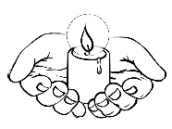
The prayers in the last two editions of the Penhill Beacon have been based on Hope and Joy. With all the tumult in the world at the time of writing these prayers are based on Peace.

‘PEACE: Pray Everyday Acknowledging Christ is Eternal’

Lord as we remember with sadness the horror of war we pray that there may be a better understanding between races and nations. Renew in all those in authority the desire for peace so that trust may replace suspicion and that your spirit of reconciliation be known across the world.

Spirit of truth and judgment, who alone can exorcise the powers that grip our world: at the point of crisis give us all your discernment, that we see what is truly evil, and know the way that leads to peace.

Here from the Mothers’ Union is a prayer:
Dear Father in heaven let us be peacemakers:
More ready to call people friends than enemies,
More ready to trust than mistrust,
More ready to love than to hate
More ready to serve than be served.
Dear Father in heaven,
Let us be more like Christ.

As we rejoice in the peace and beauty of our beautiful dale, we pray for all those who come to enjoy it with us for a short time. May they find relaxation and renewal and leave with happy memories of the welcome we gave them.

We pray for peace in our families. Feelings of love can be stretched at times but we can always offer up this simple prayer – Lord we pray for all those we love, keep them safe and give them your Peace.

And for ourselves: Lord we thank you for the peace you give us when we cease our endless worries and rushing about and find some time and space to be with You. May your love fill us, calm our fears and fill us with that true sense of Peace.
All those centuries ago St Francis summed it all up in that beautiful prayer now set to music. ‘Make me a channel of your peace’. When we feel really despondent try listening to that.

God our Father, gifts without measure flow from your goodness to bring us your Peace. When Jesus met his disciples after his resurrection his greeting to them was ‘Peace be with you’. In these anxious times what better greeting could there be?

Church on Show at the Wensleydale Show
Saturday 29th August from 9.00 am
The Wensley Deanery Churches will once again host a ‘Church on Show’ stand at the Wensleydale Show, Leyburn DL8 5JG.
Theme: Pilgrimage Journeys with children’s Trail and Forest Church activity.
Everyone is welcome to come to the stand to enjoy friendship and chat.

Carperby Open Gardens
11am – 4pm
Sunday 28th June
Quality refreshments in the Village Institute
Entry: adults £5 children free

Look Around You - The Font
Take a meditative walk around the church
The font is the starting point for many people on their journey of faith. Through the act of baptism or christening we identify ourselves with the church community. The water of baptism represents a leaving behind of the past and a commitment to God for the future. While you are in this sacred space today, perhaps there are things you would like to ‘leave behind’.
Jesus said: “Come to me, all you who are weary and are carrying heavy burdens and I will give you rest. Take my yoke upon you, and learn from me, for I am gentle and humble in heart, and you will find rest for your souls. For my yoke is easy, and my burden is light.” Matthew 11: 28-30.
‘God, help me to leave behind the things that trouble me,
and give me the peace of your presence.’
With kind permission from Look Around You © 2007 Lifewords.
Church Services: In case of bad weather please check our website penhillbenefice.co.uk/services and Facebook page for updates.
Phone services: dial 0333 0110 946 and enter room number 61337190# and PIN 7450# (Local charges apply). Everyone is welcome.

Sunday June 7th
9.30 am Telephone Service
9.30 am Holy Communion, St Margaret’s, Preston under Scar
9.30 am Morning Prayer, St Mary’s, Redmire
11.00 am Holy Communion, St Andrew’s, Aysgarth
11.00 am Holy Communion, St Bartholomew’s, West Witton

Sunday June 14th
9.30 am Telephone Service
10.30 am Holy Communion Penhill Together Service,
St Mary’s, Redmire

Sunday June 21st
9.30 am Telephone Service
9.30 am Holy Communion, St Margaret’s, Preston under Scar
9.30 am Holy Communion, St Mary’s, Redmire
11.00 am Holy Communion, St Andrew’s, Aysgarth
11.00 am Morning Prayer, St Bartholomew’s, West Witton

Sunday June 28th
9.30 am Telephone Service
9.30 am Holy Communion, St Bartholomew’s, West Witton
11.00 am Morning Prayer, St Andrew’s, Aysgarth
6.00 pm Evening Prayer, Thornton Rust Mission Room

June Mid-Week Services: Holy Communion at 9.30am
Thursday 11th & 25thJune at St. Bartholomew’s, West Witton

July Church Services:
Sunday July 5th
9.30 am Telephone Service
9.30 am Holy Communion, St Margaret’s, Preston under Scar
9.30 am Morning Prayer, St Mary’s, Redmire
11.00 am Holy Communion, St Andrew’s, Aysgarth
11.00 am Holy Communion, St Bartholomew’s, West Witton
Sunday July 12th
Penhill Benefice 20th Year Anniversary Celebration

9.30 am Telephone Service
10.30 am Holy Communion Penhill Together Service,
St Andrew’s, Aysgarth with Revd Canon Dr James Theodosius, Archdeacon of Richmond and Craven.

Sunday July 19th
9.30 am Telephone Service
9.30 am Holy Communion, St Mary’s, Redmire
11.00 am Holy Communion, St Andrew’s, Aysgarth
11.00 am Morning Prayer, St Bartholomew’s, West Witton
6.00 pm Songs of Praise, St Margaret’s, Preston under Scar

Sunday July 26th
9.30 am Telephone Service
9.30 am Holy Communion, St Bartholomew’s, West Witton
11.00 am Morning Prayer, St Andrew’s, Aysgarth
6.00 pm Evening Prayer, Thornton Rust Mission Room

July Mid-Week Services: Holy Communion at 9.30am
Thursday 9th & 23rd July at St Bartholomew’s, West Witton

Paschal Candles
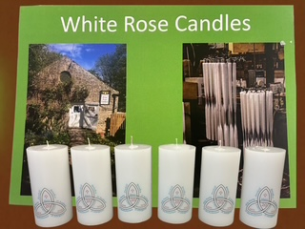
The Benefice PCCs drew up a long list of ideas to celebrate the 20th anniversary of The Penhill Benefice. One idea was to commission a set of Pascal Candles from White Rose Candles, Wensley. Another idea 'on the list' was to create a logo for the 20th anniversary and this included the name of each of our churches. This logo appears on the side of each candle and each candle has been distributed to each church having been blessed at the Benefice Service on Palm Sunday. Therefore, on Easter Sunday, we lit the different candles, at our diverse locations across the benefice, as a symbol of unity.
My Faith Journey

As we continue to celebrate the 20th Penhill Benefice Anniversary
Hilary Grisewood, a member of St Margaret’s Church, Preston under Scar agreed to share her faith journey with us.

I was never exactly introduced to church, except via baptism as a baby. My father was a vicar and he and my mother moved to a parish in Folkestone, Kent, when they married after the war and I was born there. My father’s role was to weld together two very different parishes one of which had lost its church through bombing. My parents’ vicarage was quite new, with six bedrooms and both my parents, who worked as a team, felt they couldn’t justify having such a luxurious home unless it was used for church activities.

This meant that our house was always full of people. There were people that lived with us, like a Nigerian trainee nurse who had mental health problems, a teenager who ran away from home and lived with us for 3 years and another young girl whose parents had virtually abandoned her. There were visiting missionaries and other clergy and my parents’ friends. There were short-term visiting students from India, Malaya and Africa. At the same time our house was also used as the parish office and community centre so there were weekly meetings of clergy, confirmation groups, the Mothers’ Union and the ‘young wives’ whose children took over our dining room. People were encouraged to ‘just walk in’ and there was always coffee and biscuits.

I have huge admiration for the way in which my parents’ faith was lived out day by day, and their unstinting generosity with their time. For myself though, as an only child, the lifestyle was often difficult. As I grew older I developed a line of mute resistance; I struggled to find my own beliefs and my own path, but although I was often unhappy I was always aware of God’s presence and his love for me. When I was 13 we moved to a small industrial town in Gloucestershire where I attended a number of weekends run by the diocesan youth team and these had a big impact on me because it allowed me to explore my faith in an area away from home.

Two teachers stood out; one, a Yorkshireman from a mining community who as a history teacher taught us socialism with a Christian heart and the other was an art teacher who showed me great kindness. I learnt that small acts of kindness can have a profound and lasting effect. I loved classical music from an early age and some experiences were unforgettable like an early performance of Britten’s War Requiem in Gloucester Cathedral when I was about 14. Books and music were, and still are, a main source of inspiration for me and Handel’s Messiah often reduces me to tears because to me it shows a vision of God’s love for us and our capacity for human response. The human stories in the Bible are captivating and speak to us over 4,000 years, and well-known passages can still catch me by surprise.

It was my mother’s friends who also influenced me; they were variously Jewish, communist and gay in various combinations – an improbable addition to vicarage life! Some of them became close friends of mine and through them I heard about social work, at that time a very new profession, and I chose that; it lasted me until I retired. I always worked at the ‘coal face’ in local authority work, mainly in children’s services in South Yorkshire and I loved it. It was a gift to meet and work with people whose everyday generosity, warmth and humour was often astonishing. Saints abound, but we often don’t recognise them.

I met my husband through social work. He was and is a Catholic and although the differences in our beliefs can cause us pain there is so much that we share and we benefit from being part of two different but overlapping Christian communities.

I think I have always found God in unexpected places and amongst unconventional people and situations. But I believe we need a church and need the guidance, nourishment and inspiration of others and few of us can maintain a solitary religious life. The regular services, especially the communion service, are essential for me.

Two Benefice Anniversary Walks
Friday 24th and Saturday 25th July. Walk from church to church across the Benefice, about 8 miles per day. Tuesday 4th to Friday 7th August. Walk around the perimeter of the Benefice over four days. More details to follow. See website and Facebook page for updates about the walks.

The Sonrise Walk and Service
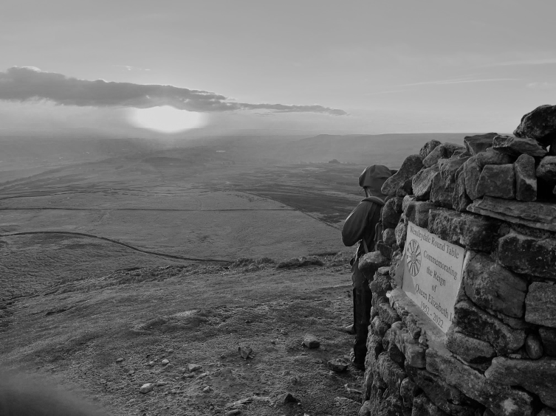
The idea seemed a good one but as Easter approached it seemed an example of optimism over realism: to get up very early soon after the clocks had changed, assemble at the foot of Penhill when still dark and climb to the top.
There we would hope to see the sunrise and to share a short service to celebrate the reality of our risen Lord that is announced at Easter. There was a sense of mutual surprise that over twenty of us shared this optimism and we were more than rewarded both by each other's company and the stunning sight of the rising sun over the Yorkshire Moors. We paused, we read, we listened and we sang. Accompanied by the glow of the warming sun we returned and gathered again for welcomed bacon rolls received with gratitude at West Witton.
Memory making. Life giving.

Penhill Benefice 20th Anniversary – Fun Fact!

The four PCCs have now held their Annual Parochial Church Meetings (APCMs) during April and May of this year. That might not sound extraordinary at first… until you realise that across 20 years as a Benefice, altogether that adds up to a grand total of 80 annual meetings!

Back when the Benefice first began, parish administration looked very different from today. Many PCC members didn’t have access to computers so individual reports were often handwritten and physically brought to the office to be typed up and collated into one annual report per parish. The administrator worked at the ‘newly set up office’ in the vicar’s study at the vicarage!
Technology had its own quirks back then. In the days of dial-up internet, the telephone and internet couldn’t be used at the same time.
If the vicar or administrator was online the other couldn’t make a phone call without causing chaos. Younger readers may need to ask someone over 40 what that strange screeching connection noise sounded like…

The annual report forms themselves were posted out from the diocese to the vicarage, then individually sorted, packed and hand-delivered to each PCC. A far cry from today’s world of attachments, shared documents and instant replies.

Now, with a few clicks, we can happily “ping” emails and forms back and forth in seconds — something that would have seemed wonderfully advanced 20 years ago.

Perhaps the APCMs haven’t become shorter over the years… but at least the paperwork journey has!

Don’t Step on a Bee Day – 10th July
The eye-catching name of this annual event aims to remind people of how important bees are in our ecosystem and of the need to promote their protection. Don’t Step on a Bee Day highlights the crucial role bees play in pollination and also that their populations are declining, because of habitat loss, pesticides and climate change.

If you want to help the bees, here is what you can do:

Plant Bee-Friendly Flowers: Grow a variety of flowers in your garden that attract and support bees, such as lavender, sunflowers and marigolds.

Avoid Using Pesticides: Reduce or eliminate these in your garden to create a safer environment for bees.

Support Local Beekeepers: Purchase honey from local beekeepers to help support sustainable beekeeping practices.

Create a Bee Bath: Place a shallow dish of water with stones in your garden to provide bees with a safe place to drink.

Educate Others: Share information about the importance of bees and how you protect them with friends, family and on social media.
Telephone Directory

JULIE IVESON PSYCHOTHERAPEUTIC COUNSELLING, BACP Registered Psychotherapeutic Counsellor Level 6 DIP. www.julieivesontherapy.com Email: julieivesontherapy@gmail.com Mob: 07825467508. In person at
Leyburn Arts & Community Centre, The Old School House, Richmond Rd, Leyburn DL8 5DL. Online via Microsoft Teams or Telephone. I offer a safe and confidential space to explore your personal issues.

JONAS CENTRE Redmire, Leyburn, DL8 4EW; Tel: 01969 624 900; www.jonascentre.org A Christian residential centre and holiday venue just by the village of Redmire. Our vision is people knowing God more, so we welcome all to share in a beautiful place, set aside for resting, seeking and engaging with God. Come and stay for a holiday retreat, or bring a group on a residential break.

CLARKSONS Thornborough Hall, Leyburn, DL8 5AB. Tel: 01969 624999.
www.clarksonsaccountants.co.uk email: info@clarksonsaccountants.co.uk
Whatever your accounting or business needs, we offer a personalised service to help make life easier and support you in fulfilling your business’s potential.

WEST WITTON VILLAGE HALL, Tel: 01969 623 813. (Peter Sadler). Reasonable hire rates. (Table Tennis played every Wednesday evening)
Do you need to hire a village hall for a party, dance or other special event? West Witton Village Hall is your venue!

J ROBERT FOSTER Approved Coal Merchant, Swan Farm, Redmire, Leyburn, DL8 4HA Tel: 01969622 331/07811 385 392
Selling quality house coal and smokeless fuel.

HAMILTON’S TEA ROOM, Yoredale House, Aysgarth Tel: 01969 663 423
www.yoredalehouse.com info@yoredalehouse.com Open 10.30am to 4.30pm February to November. Closed Monday and Tuesday. Licensed village tea room. Homemade food. Breakfast, light lunches and clotted cream teas.


JASON THOMAS PHOTOGRAPHY, Aysgarth, Leyburn,
North Yorkshire www.jasonthomasphotography.biz
M: 07908 809 895. info@jasonthomasphotography.biz
‘Providing an affordable, Professional Photography service in the Yorkshire
Dales and beyond’
W.S.HARTLE FAMILY BUTCHER, West Burton, DL8 4JN Tel: David 01969 663 302. www.hartlebutchers.co.uk Free local delivery and freezer orders. Best Quality Meat, West Burton Spring Lamb, Homemade Sausages and Burgers.

WHITE ROSE CANDLES, Wensley Mill Wensley Leyburn DL8 4HR
Tel: 01969 623 544 **CarPark**Waterfall**Admission Free** www.whiterosecandles.co.uk whiterosecandles@btinternet.com Open Feb
to Oct Wed-Sat: 10am-4.30pm. Nov/Dec: Wed-Sat 10am-Dusk until Christmas. If making a special journey it is wise to ring and check details. Church candles are one of our specialities, also dinner, pillar and aromatherapy candles. All made in Wensley. Commissions accepted.

SANDERSON & CO Funeral Directors, Leyburn Business Park Harmby Road, Leyburn, North Yorkshire DL8 5QA Tel: Leyburn 01969 623 143
Mobile: 07710 652 348 sandersonandco@btconnect.com Written details on request. Complete 24 hour Service. A Family Business. Established over 100 Years. Personal Attention. Private Chapel Of Rest. Golden Charter
Pre-Payment Plans available.

THE WONKY TREE BOOKSHOP, Market Place, Leyburn DL8 5BD.
Phone: 01969 625927 Email: info@thewonkytreebookshop.co.uk

Website: www.thewonkytreebookshop.co.uk
Opening: Tuesday - Saturday 10am - 4.30pm
Independent family run bookshop.
Wonderfully curated collection of books for adults and children.
Beautiful cards and gift wrap alongside a unique selection of gifts.
Fast ordering and postal delivery service available.

THE WENSLEYDALE EXPERIENCE, Swinithwaite, Leyburn DL8 4UH

www.wensleydale-experience.com Award-winning authentic farm stays & immersive dales experiences in the heart of Wensleydale. Perfect for visiting family and friends! Exclusive local discounts available; simply email us quoting Penhill Beacon: Enquiry@Wensleydale-experience.com

BEDALE BURNERS, Phone: 01677 450 389 Email: tony@bedaleburners.co.uk
Service and Maintenance of oil boilers and cookers.

We ask that you are mindful of the environment and kindly remove cellophane and ribbon when placing fresh flowers at the graveside of loved ones in our churchyards.

